A DIVINE MOVEMENT UNITED IN MISSION AND MESSAGE  Mark A. Finley | 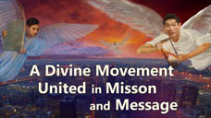  1
Unity: Then and Now | 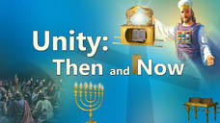  2
One of the things that really matters to God is the unity of His church. The unity of the church is not some periphery matter. It is at the very heart of the gospel. Without unity the church is powerless to proclaim the gospel in its fullness to the world and worse yet it becomes a contradiction to the true nature of the gospel. | 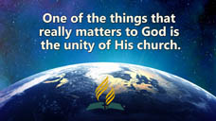  3
Jesus revealed the importance of unity in His final intercessory prayer when He prayed,  John 17:23  “I in them, and you in Me; that they may be made perfect in one, and that the world may know that you have sent me, and have loved them as you have loved me.”  One of the greatest evidences of the power of the gospel is the unity of the church. When people of different backgrounds, cultures, languages and dispositions are united by the Holy Spirit in Christ, the world notices. Writing with divine insight, Ellen White puts it this way, | 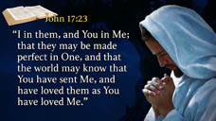  4
Acts of the Apostles p. 90  “Only as they were united with Christ could the disciples hope to have the accompanying power of the Holy Spirit and the co-operation of angels of heaven. With the help of these divine agencies they would present before the world a united front and would be victorious | 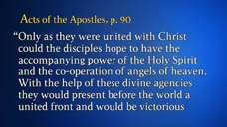  5
in the conflict they were compelled to wage unceasingly against the powers of darkness. As they should continue to labor unitedly, heavenly messengers would go before them, opening the way; | 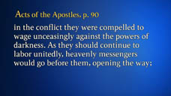  6
hearts would be prepared for the reception of truth, and many would be won to Christ.” | 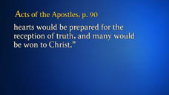  7
The Acts Model: A United Church  One of the most striking New Testament examples of a unified church is the church in the book of Acts. Although there certainly were differences of background and culture and at times heated debates, at its very core the New Testament church exhibited unity. | 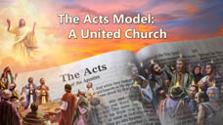  8
This unity was not a uniformity of understanding on each issue, neither was it a sweet, superficial sentimentalism. It was not some vague, undefinable pluralistic “oneness” where each tolerated the others personal views to accomplish some larger ethereal goal. | 9
New Testament unity was a unity of faith rooted in the person, message and mission of Christ. The story of the Book of Acts is the story of believers brought together by the Holy Spirit in a divinely inspired movement to impact the world.  It is the history of Bible believing, Christ-centered, men and women passionate about God’s mission through His church. | 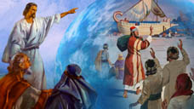  10
United in the Centrality of Christ’s Love  The disciples were united in their love for Christ. Committed to Christ they were drawn close together. Their bond of union was forged in Him. Christ was their all in all.  Charmed by His love, redeemed by His grace, and empowered by His Spirit they were, in spite of their differences, united in one body.  Ellen White uses an interesting expression to describe the unity of the disciples. | 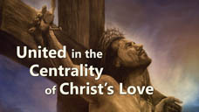  11
Acts of the Apostles p. 28  “Christ’s name was to be their watchword, their badge of distinction, their bond of union, the authority for their course of action, and the source of their success. Nothing was to be recognized in His kingdom that did not bear His name and superscription.”  Christ’s Name was their “bond of union.”  In other words they were one in an indissoluble union with Christ. | 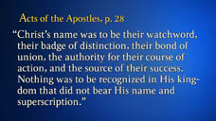  12
Revivalist A. W. Tozer puts it this way, “Has it ever occurred to you that one hundred pianos all tuned to the same fork are automatically tuned to each other? | 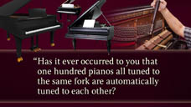  13
They are of one accord by being tuned, not to each other, but to another standard to which each one must individually bow. So one hundred worshipers [meeting] together, each one looking away to Christ, are in heart nearer to each other than they could possibly be, were they to become 'unity' conscious and turn their eyes away from God to strive for closer fellowship.”  (A.W.Tozer, In Pursuit of God) | 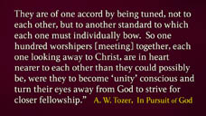  14
Tuned to Christ, the disciples were tuned to one another. Christ is the great unifier.  Speaking of Christ bridging the divide between Jews and Gentiles, the apostle Paul emphatically declares, | 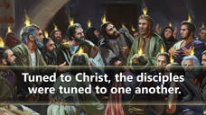  15
“For He Himself is our peace, who has made both one, and has broken down the middle wall of partition between us…” Ephesians 2:14  The apostle goes on to say that in Christ,  “the whole body is joined and knit together.” Ephesians 4:16  and pleads with the church at Corinth that there “be no schism in the body.” 1 Corinthians 12:35  When hearts are one in Christ they cannot be too far apart. | 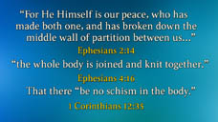  16
Could it be that at times our disunity is the result of having drifted from the heart of Christ?  Is it possible that our own personal opinions and ideas about a given subject cloud Christ’s will on that thing and create dissension between us?  Do you think pride ever obscures our vision?  Might it also be that the reason the disciples were of “one accord” on the day of Pentecost is because they unashamedly surrendered their wills to the will of Christ and were willing to surrender anything that separated them from Him and one another?  New Testament unity was based on a common commitment to Christ, His message and His mission? | 17
United in the Centrality of Christ’s Message  The unity of the New Testament Church was anchored in the disciple’s commitment to the message of Christ.  It is often overlooked that when Jesus prayed for the unity of His church, He prayed that His Father would, | 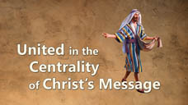  18
John 17:17  “Sanctify them by your truth, Your Word is truth.”  The unity of the New Testament Church was based on a common commitment to Jesus’ revealed truth.  New Testament believers accepted the truth about the authoritative revelation of scripture, salvation by faith, the ministry of the Holy Spirit, the second coming of Christ, the Sabbath, death, resurrection and Christ’s priestly ministry just to mention a few of our Lord’s central teachings.  They were brought together through His prophetic Word, bonded in truth and committed to the divine revelation of His will. | 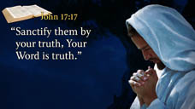  19
Luke describes the union of New Testament believers in Acts 2:41,  “Then those who gladly received His Word were baptized; and that day about three thousand souls were added unto them. And they continued steadfastly in the apostles’ doctrine and fellowship, in the breaking of bread and prayers.” | 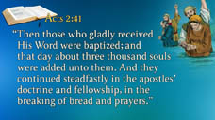  20
Notice two significant expressions,  1) those who gladly received His Word and  2) they continued steadfastly in the apostle’s doctrine.”  Both of these expressions imply an acceptance of and commitment to the unchanging, eternal truths of scripture.  The unity of the New Testament believers was based on their common commitment to the teachings of Jesus as found in His Word. They were united in the bedrock, foundational truths of scripture. | 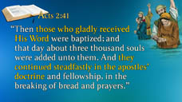  21
Charles Spurgeon spoke of unity in the truth in these straightforward words, “A chorus of ecumenical voices keep harping the unity tune. What they are saying is, ‘Christians of all doctrinal shades and beliefs must come together in one visible organization, regardless... Unite, unite!’ Such teaching is false, reckless and dangerous. Truth alone must determine our alignments. Truth comes before unity. Unity without truth is hazardous. | 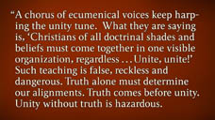  22
Our Lord's Prayer in John 17 must be read in its full context. Look at verse 17: "Sanctify them through thy truth; thy word is truth." Only those sanctified through the Word can be one in Christ. To teach otherwise is to betray the Gospel. (Charles H. Spurgeon, The Essence of Separation, quoted in the Berean Call, July 1992, p.4) | 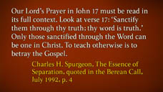  23
Ellen White would agree with Spurgeon. Commenting on Jesus prayer for unity in John 17, she writes,  Gospel Workers, p. 92  “We cannot surrender the truth in order to accomplish this union; for the very means by which it is to be gained is sanctification through the truth. Human wisdom would change all this, thinking this basis of union too narrow. | 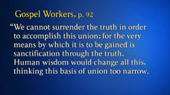  24
Men would effect a union through conformity to popular opinions, through a compromise with the world. But truth is God’s basis for the unity of his people.  The New Testament Church was united through a prophetic present truth message. Peter’s masterful presentation in Acts 2 was a prophetic message clearly revealing Jesus as the promised Messiah.  In Acts 8, Phillip’s prophetic Bible study on Jesus as the Messianic fulfillment of Isaiah 53 led the Ethiopian to a decision for Christ and Paul’s prophetic preaching in Acts 17 in Thessalonica for three consecutive Sabbaths touched Jewish hearts. | 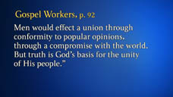  25
The truth as it is in Jesus prophetically proclaimed unified the church in a common mission. Truth unites.  There is something larger, something greater, something grander than our personal opinions or even our individual convictions.  The truth of the Word revealed by the Spirit supersedes everything else.  When the people of God are united in Christ to proclaim the prophetic Word of God in the power of the Holy Spirit the earth will be lightened with the glory of God. Once again in this generation God has entrusted His people with a prophetic present truth message. | 26
God has given divine insight on what is coming upon God’s end time people. Subtle errors, falsehoods, in the name of truth will gradually enter in among God’s people.  Selected Messages, v. 1, p. 204  “The enemy of souls has sought to bring in the supposition that a great reformation was to take place among Seventh-day Adventists, and that this reformation would consist in giving up the doctrines which stand as the pillars of our faith, and engaging in a process of reorganization. | 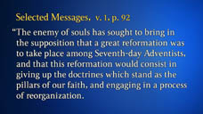  27
Were this reformation to take place, what would result? The principles of truth that God in His wisdom has given to the remnant church, would be discarded. Our religion would be changed. The fundamental principles that have sustained the work for the last fifty years would be accounted as error.”  It is the message of Christ our righteousness in light of the Three Angels Messages of Revelation 14:6-12 that will unite His people in one final end time proclamation of truth.  It is the Bible based, Christ-centered, last day prophetic message of present truth for this hour that will move the world so it will be written of God’s people that | 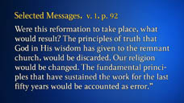  28
Acts 17:6  “Those who have turned the world upside down have come here too.” | 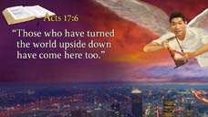  29
United in the Centrality of Christ’s Mission  The New Testament Church was united in a single-minded passion of sharing Christ and the message of the gospel with the world.  Personal preferences and opinions were secondary to the proclamation of the message of the cross.  Overwhelmed by grace, amazed by the goodness of God and awestruck by the redemption that is in Christ, the disciples overcame their petty differences in light of Christ’s larger mission.  The one thing that overshadowed everything else was a world in need of Christ’s saving grace and the certainty of the life changing Word. | 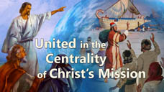  30
In Acts 4 verse 20 when the authorities attempted to silence His voice, Peter proclaimed, “For we cannot but speak the things we have seen and heard.”  Acts 5:42 adds, “And daily in the temple and in every house, they did not cease teaching and preaching Jesus as the Christ.”  When persecution broke upon the disciples the record reveals that, “…those who were scattered went everywhere preaching the Word.”(Acts 8:4)  The disciples had their differences. At times there were misunderstandings and even conflict but they were united in Christ to proclaim a present truth prophetic message that the world so desperately needed to hear.  Their, unswerving single minded purpose was to accomplish God’s mission.  They had fellowshipped with the Savior and His passion to “seek and save the lost” became their passion. (Luke 19:10) It was their commitment to Christ, His message and mission that kept them focused on their task.  There are two classic statements in the book Acts of the Apostles that powerfully portray the purpose and the focus of the early church. | 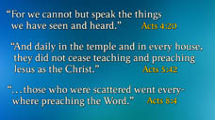  31
Acts of the Apostles, p. 9  “The church is God’s appointed agency for the salvation of men. It was organized for service, and its mission is to carry the gospel to the world.” | 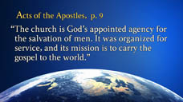  32
Acts of the Apostles, p. 37  “Putting away all differences, all desire for the supremacy, they came close together in Christian fellowship. They drew nearer and nearer to God, and as they did this they realized what a privilege had been theirs in being permitted to associate so closely with Christ. | 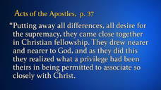  33
Sadness filled their hearts as they thought of how many times they had grieved Him by their slowness of comprehension, their failure to understand the lessons that, for their good, He was trying to teach them. These days of preparation were days of deep heart searching. | 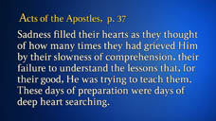  34
The disciples felt their spiritual need and cried to the Lord for the holy unction that was to fit them for the work of soul saving. They did not ask for a blessing for themselves merely. They were weighted with the burden of the salvation of souls. | 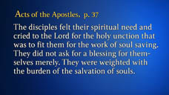  35
They realized that the gospel was to be carried to the world, and they claimed the power that Christ had promised.” | 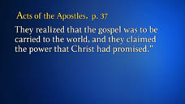  36
The clear focus, the overriding purpose of the first century church was winning the lost to Christ.  This one thing triumphed over personal ambition, the desire for supremacy and human strivings for position or power. They were willing to sacrifice their cherished ambitions to maintain a unified focus on soul winning.  The New Testament Church was united in Christ with a passion for His passion–saving lost people. For them church organization stimulated this unity by providing a structure to grow in the truth of His Word and foster the proclamation of the Word. | 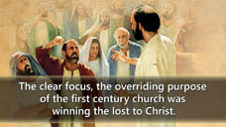  37
United in the centrality of His Church  Throughout the New Testament, Jesus emphasized the divine nature of the church. When Peter confessed that Jesus was the divine Son of God, our Savior replied, “…On this rock I will build my church and the gates of hell shall not prevail against it.”(Matthew 16:18)  The church is not some human, bureaucratic, manmade institution. It is a divine movement raised up by God. Its purpose is to nurture and foster the spiritual life of each believer and equip each one to use their gifts in the proclamation of the gospel in a life of self-sacrificial service to others. | 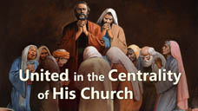  38
The church is the “body of Christ”, “the flock of God”, the “pillar and ground of the truth”, “a holy temple” and the “remnant of His seed.”  It is “God’s appointed agency for the salvation of men. It was organized for service, and its mission is to carry the gospel to the world.”(AA. p 9) | 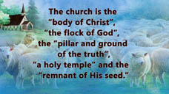  39
Church Organization in a Growing Church  Christ organized the church Himself when He personally ordained the twelve disciples. The scriptural record states, | 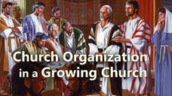  40
Mark 3:13, 14  “And He ordained twelve, that they should be with Him, and that He might send them forth to preach.”  Ellen White leaves no doubt about the significance of this act when she states | 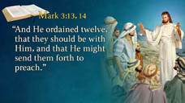  41
Acts of the Apostles, p. 18  “It was at the ordination of the Twelve that the first step was taken in the organization of the church that after Christ’s departure was to carry on His work on the earth.”  It is fascinating to observe that the “first step” in this organizational process was the ordination of the twelve disciples who then became the spiritual leaders of the early church. The ordination of the twelve was a crucial step in Christ’s plan for accomplishing heaven’s mission to the world.  The church’s organizational structure continued to grow and more fully develop in the early decades of Christianity. | 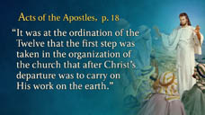  42
In the book of Acts church organization is paramount to the unity of the church.  Without organization the church’s message could easily have been hijacked by false teachers and its mission sidetracked.  Without church organization the Biblical message of truth based on the Word of God would have been distorted and the mission of Christ diluted.  Let’s review church organization in the book of Acts and notice its function in nurturing believer’s spiritual life, preserving the church’s message and fostering its mission. | 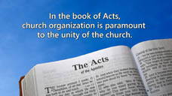  43
In Acts 1, a united group of 120 believers met in the upper room to pray for the outpouring of the Holy Spirit. (Verse 14) They were united in their love for Christ. They were committed to His teachings.  Their hearts beat with an overwhelming desire to share His love with everyone they met. The record states that they were in “one accord” seeking God for the outpouring of His Spirit and power to reach the world. (Acts 1:8, 14, 15) | 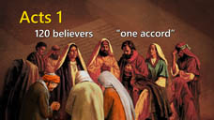  44
A potential problem arose at the end of the chapter. The position vacated by Judas betrayal and death needed to be filled. The early church considered two of their number as possibilities. This could have been problematic.  These New Testament believers could easily have taken sides with hardened positions on the name they thought was God’s will for the position. | 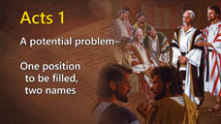  45
They mutually agreed to seek God’s wisdom on the matter. (Verse 24)  The fact that they chose two and were only going to select one indicates that there were differences of opinion among the group.  This experience of selecting one over the other could easily have divided the church but they agreed on a process of discerning God’s will and also agreed to accept the outcome.  They were willing to surrender their own convictions to the revealed will of Christ through the selection process. Even in its embryonic stage the church was learning lessons of submission for the sake of unity and mission. | 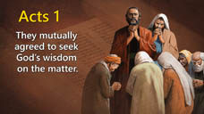  46
In Acts 2, 3000 were baptized on the day of Pentecost. They united with the church and continued steadfastly in the apostle’s doctrine, fellowship and prayers. (Verse 41)  Those baptized became part of an organized movement. They were taught the “apostles doctrine”, enjoyed the believers “fellowship” and joined in the congregation’s “prayers.” | 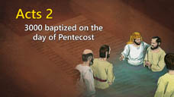  47
According to Acts 6, as the church grew it faced new challenges. The Greek widows were not receiving their fair proportion in the food distribution.  Once again there was open discussion and a mutually agreed upon solution. | 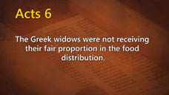  48
A representative group of deacons was chosen.  These deacons ministered to the needy Greek widows and maintained the unity of the church in a time of crises.  They were chosen because they had “good reputations”, were “full of the Holy Spirit” and were guided by divine “wisdom.” (Acts 6:3)  At each step of its development, the early church refined its organizational structure for the sake of nurturing the growing church, safeguarding its teachings and fostering its mission. | 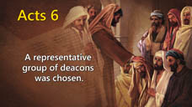  49
Acts 9 records the conversion of the apostle Paul. Immediately upon his Damascus Road conversion, the Holy Spirit led him to Ananias a representative of the church.  The Spirit did not at this juncture lead him into the wilderness to spend time alone, neither did the Spirit send him out immediately on an evangelistic mission. He was brought into contact with a representative of God’s church.  One reason for this is to illustrate the importance of church organization and authority.  In the book Acts of the Apostles, Ellen White, puts it this way, | 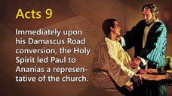  50
“Thus Jesus gave sanction to the authority of His organized church and placed Paul in connection with His appointed agencies on earth.” (AA p.123)  Paul was nurtured in his faith by Ananias and further taught about God’s plan of church organization. | 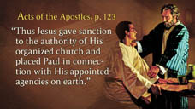  51
In Acts 15, the New Testament Church faced a critical juncture in its development. A conflict arose over how Gentile believers who now had accepted Christ should relate to Jewish customs and especially circumcision.  This was no little matter. Circumcision had been practiced by Jewish believers for millenniums. It was part of their identity deeply imbedded in their culture. Consequently, Paul and Barnabas had “no small dissension and dispute” with these Jewish leaders. (Acts 15:2)  They mutually agreed to refer the matter to the Jerusalem Council. The Jerusalem Council had the authority to make a decision that not everyone was pleased with but the majority of the church accepted. Its decision was accepted by the church at large and brought unity to the body of believers. | 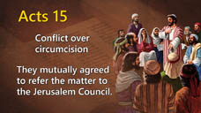  52
Unity came as individuals surrendered to the authority of the larger body.  My point here is not the decision that was made but the process by which it was made. A complex issue was brought from the local church to a larger administrative body.  Both the leadership and membership agreed to accept the decision of the Jerusalem Council.  Writing with prophetic insight, Ellen White describes the authority vested in the Jerusalem Council in these poignant words, | 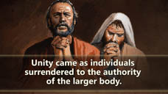  53
“Meanwhile all controversy was to cease until a final decision should be given in general council. This decision was then to be universally accepted by the different churches throughout the country. (AA 190)  A very difficult issue that was troubling Christianity was settled by the willingness of both sides to accept the decision of the Jerusalem Council.  People had convictions on both sides of this question but most were willing to accept the decision of a representative body of leaders for the sake of God’s mission. | 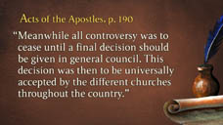  54
This general meeting of believers with delegates from varying churches brought unity to the body of Christ and once again they focused on what is the most important thing on God’s heart-the saving of lost people.  Think of what could have happened if the rest of the book of Acts was spent discussing the varying sides of a debate over circumcision for Gentile converts to Christianity. Imagine the tragic impact on the growth of the church an endless debate on this matter would have had.  Wisely the New Testament Church accepted the decision of the larger body, the general Council of the church, and passionately moved on with mission. | 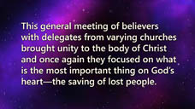  55
In Acts 20:17-32, the apostle Paul instructed the elders of the church on both building up and safeguarding the flock of God.  He counseled them that one of the functions of church organization and an ordained ministry was to protect the church from false teachers and keep it focused on mission.  Once again he emphasized the importance of church organization and its relation to both building the faith of the church members and protecting them from false teachers. | 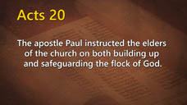  56
Paul’s letters to Ephesus, Philippi, and Colossae and his counsel to Timothy and Titus indicate a cohesive organizational structure with elders, deacons and deaconesses.  A financial sharing plan emerges as Paul takes an offering for the suffering believers in Jerusalem and encourages that “those who preach the gospel shall live from the gospel. (1 Corinthians 9:14) | 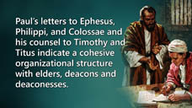  57
Church Organization: An Essential Element of Unity  The New Testament Church was unified in its commitment to Christ, its commitment to His present truth, prophetic message, His mission to the world and His divinely established church organization.  We are on a very slippery slope if personal opinions or preferences are placed over and against the authority of Christ’s organized church.  Ellen White states it clearly, | 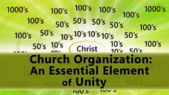  58
Testimonies, v. 9, p. 258  “Oh, how Satan would rejoice if he could succeed in his efforts to get in among this people and disorganize the work at a time when thorough organization is essential and will be the greatest power to keep out spurious uprisings and to refute claims not endorsed by the word of God! | 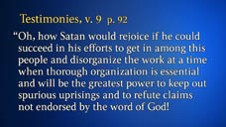  59
We want to hold the lines evenly, that there shall be no breaking down of the system of organization and order that has been built up by wise, careful labor.”  Church organization and its subsequent policies based on Biblical principles play an indispensable role in unifying Christ’s church.  Rather than being arbitrary decrees by authoritarian leaders, the church’s policies are mutual agreements based on trust.  They outline how the church functions. They are developed by a broad base of representative leadership. | 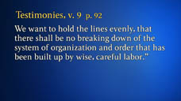  60
The church’s policies are not infallible. They can change and sometimes do but they represent the best judgment of a representative group of leaders at a given period of time.  They are agreements guided by the Holy Spirit to determine the best way forward for the church.  They are not to be equated with salvation or timeless biblical truths but they are one of the cohesive elements that holds the church together. | 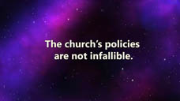  61
Policies: Mutual Agreements Based on Trust  For example, the Bible is clear in its teaching of the tithing principle but it does not delineate tithe percentages to varying entities from the local church to the Conference, Union and Division.  These decisions are made by committees.  What would happen if each church or local conference decided for itself how much of its tithe to retain and how much to pass on to the Union Conference or Division?  The church would have a financial disaster. Its ability to function as a world body would be severely curtailed. | 62
Here is another example. The Seventh-day Adventist Church has 28 Fundamental Beliefs. Why not 25 or 30?  Who determines there are only 28 Fundamental Beliefs?  The Bible does not specify or enumerate exactly 28. In fact recently the 28th Fundamental Belief was added to the church’s list of Fundamentals.  What if each local field determined the Fundamental Beliefs they thought were appropriate to their culture and territory and left the others out?  The issue here is not the Biblical truth of the Fundamental Belief but the determination of what a Fundamental Belief is and how many to include.  This is a decision of responsible church leadership mutually agreed upon by the General Conference in Session. | 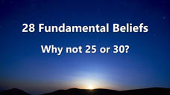  63
When We Differ | 64
The scriptures are a revelation of God’s eternal, unchanging, authoritative truths.  In the development of policy, the principles of scripture guide the church and the role of church leadership is to always be faithful to this sacred trust.  There will be some issues where honest people see things differently. In these instances the gospel invites us to treat one another with respect and dignity.  But this one thing is clear. The gospel also demands that we place a high priority on the unity of the church and respect the decisions of the corporate body.  The unity of the church is near to the heart of God and the organization of the church is a central truth in the New Testament.  Without church organization we would quickly have a congregational system of theological pluralism, weakened mission and organizational chaos. | 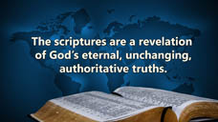  65
Ellen White echo’s this critical thought,  “God has ordained that the representatives of His church from all parts of the earth, when assembled in a General Conference, shall have authority.” (Testimonies v. 9, p. 260,261)  The unity of the church is a clear, unequivocal, Biblical doctrine. To disregard or minimize the corporate decisions of representatives of the world church creates disunity and pains the heart of God. | 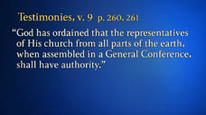  66
The unity of the church is maintained when our commitment to Christ is foremost, when we are united in the truths of Scripture through the guidance of the Holy Spirit, when we place priority on mission and are moved by what moves the heart of God | 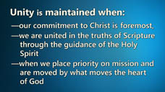  67
and when the mutual agreements or policies of the church serve as the foundation for a system of church governance and authority.  To neglect any one of these four aspects of unity is to invite disunity, a dismantling of Biblical truth, and a distortion of mission. To downplay church organization or authority is to leave the church in disarray and fundamentally erode its mission. | 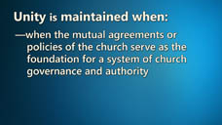  68
May we be filled with the Spirit of Christ, proclaiming the message of Christ, fulfilling the mission of Christ and upholding the church of Christ.  Then and only then will the church arise to fulfill its destiny and reveal the glory of God to a waiting world and a watching universe. | 69

